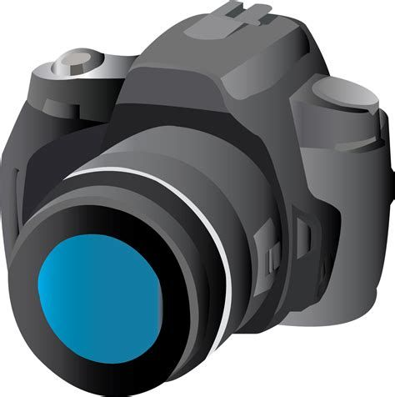
Wabakimi Rendezvous
Photo/Video Contest, 2022
Entry/Release Form
Please type or print legibly the information requested below. This entry/release form must be completed and turned in along with each individual photo or video submission. Each file or link must be titled in this manner: EntrantLastName_Title (the same as the title listed below). Example: Smith_Wabakimi Sunset
Return items to: info@wabakimi.org by deadline. Items include jpeg files (10MB or less), video YouTube links, Entry/Release Form, and, if needed, copyright material use permission documents.
Deadline: Aug 1, 2022. See Guidelines for requirements and contest details.
*********
Check one: Photo ____ Video:____
Title: ___________________________________________
Brief Description/Summary: _________________________________________________________________ ______________________________________________________________________
Entrant Name:
Address:
Phone:
Email:
Release (Please read and sign):
By submitting a photo or video, individuals agree to allow Friends of Wabakimi (FOW) to use their photos/videos for marketing, promotion, information and education purposes, at no cost. FOW reserves the right to publicize and promote the photo or video for their own purposes. All work will be given credit to the creators. The winning video submissions may be branded with the FOW’s logo at the discretion of FOW. The FOW does not assume responsibility or liability for any video or portion thereof, or for any claims, damages, or losses resulting from the use or dissemination of any video submitted in this contest. The judges’ decision is final. Entrants agree to be bound by the official contest rules, guidelines and decisions of the judges.
_______________________________________ ___________________
Entrant Signature Date

