Wabakimi Rendezvous
Video Contest, 2022
Criteria for Judging
Video
- Video met requirements outlined in contest guidelines.
Yes No
- How well did the video content fit the theme of the video contest?
1 2 3 4 5 6 7 8 9 10
- How captivating is the video? (keeps audience interest due to beauty, action, interesting events, etc)
1 2 3 4 5 6 7 8 9 10
- How creative is the video? (original style/filming/added touches)
1 2 3 4 5 6 7 8 9 10
- How well is the video produced? (visual/sound quality, steady camerawork, editing, overall presentation)
1 2 3 4 5 6 7 8 9 10
This video should be recommended for FOW webpage/Facebook upload Yes__ No __
Total Points ______/40
Comments/Notes from Judge:

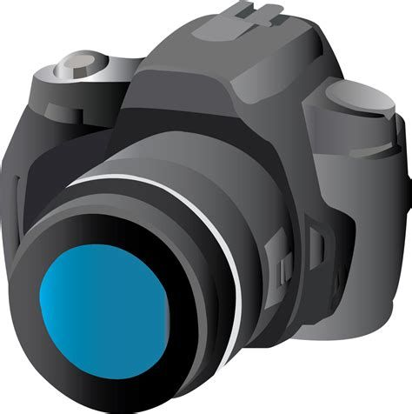
Wabakimi Rendezvous
Photo Contest, 2022
Criteria for Judging
Photo
- Photo met requirements outlined in contest guidelines.
Yes No
- Adherence to Theme (as stated above)
1 2 3 4 5 6 7 8 9 10

- Entertainment Quality (gets audience interest with beauty, action, interesting events, etc)
1 2 3 4 5 6 7 8 9 10
- Overall Artistic Impression
1 2 3 4 5 6 7 8 9 10
- Wow Factor
1 2 3 4 5 6 7 8 9 10
- Overall production quality of photo (Color, Lighting, Exposure and Focus)
1 2 3 4 5 6 7 8 9 10
This video should be recommended for FOW webpage/Facebook upload Yes__ No __
Total Points ______/50
Comments/Notes from Judge:

